

QB - Project Management
High Level Design

Written by: Avishai Abahel
Date: June 2024

Contents
1 Grids and Dashboards 3
1.1 Grids 3
1.1.1 Projects 4
1.1.2 Systems 4
1.1.3 End users/Customers 6
1.1.4 Warranties 6
1.1.5 Renewals 7
1.1.6 Infrastructure 7
1.1.7 Upgrade Management 8
1.2 Dashboards 9
1.2.1 General 9
1.2.2 Deliveries 11
1.2.2.1 Summary 11
1.2.2.2 Live systems 12
1.2.2.3 Load of work by systems 13
1.2.2.4 Renewal & Churns 14
1.2.2.5 Users/Licenses growth 15
1.2.2.6 Users/Licenses ratio 16
1.2.2.7 Hosting 17
1.2.2.8 Product growth 18
1.2.2.9 Load of work by Product 19
1.2.2.10 Modules & Configuration 20
1.2.2.11 Regions & Countries 21
1.2.2.12 Modules distribution by regions 22
1.2.2.13 AI configuration 23
1.2.2.14 AI Distribution 24
1.2.2.15 Webloc Distribution 25
1.2.3 POCs 26
1.2.3.1 Summary 26
1.2.3.2 POC per Year 27
1.2.3.3 Success rate and Cost 28
1.2.3.4 Load of work by system 29
1.2.3.5 Load of work by product 30
1.2.3.6 Hosting 31
1.2.3.7 Modules configuration 32
1.2.3.8 Regions & Countries 33
1.2.3.9 Modules distribution by region 34
1.2.3.10 AI configuration 35
1.2.3.11 AI Distribution 36
1.2.3.12 Team Activity 37

Dashboards

General
For all the grids in this chapter:
- Each column should be:
  - Filtered.
  - Sorted.
  - Grouped by.
  - Partially - a link to the relevant object.
- Any user will be able to create private grids at his convenience based on the below grid by adding/hiding columns, adding filters, formulas etc.
- Any grid should be able to be exported to one of the following formats:
  - CSV
  - Excell
- Any user will be able to create private reports and dashboards using existing grids including generating pivot tables and any kind of graphs.
- Grid should not be editable for authorized users only.

Projects

Column | Display type | Comments
Project ID | String
Project name | String
End user code name | String
Paying entity | String
Region | String
Country code name | String
Status | Icon + string | Icon color according to the status
Delivery date | Date | EU date format with the option to change it to US format in the user level only
POC start date | Date | EU date format with the option to change it to US format in the user level only
POC end date | Date | EU date format with the option to change it to US format in the user level only
Brand | Icon
Type | String
Upsell yes/no | String | Yes/No fixed text
Standard yes/no | String | Yes/No fixed text
Down sell yes/no | String | Yes/No fixed text
Hosting | String
Product | Icon | List of products. Icon per product type
Modules | Icon | List of modules. Icon per module type
Licenses | Integer
Users | Integer
Alerts | Icon + string | Icon color and shape according to the alert
Progress bar | Graphic + text | Calculated by the formula:  Implemented tasks / total number of tasks  Displaying the percents in text next or on the progress bar
Financial profile | String
Last milestone | String
Last task | String
Current milestone | String
Current task | String
Owner | String

Systems

Column | Display type | Comments
System ID | String
Project ID | String
Project name | String
Project type | String
Renewal project ID | String
Operation status | Icon + string | Icon is updates per system operation status
Region | String
Country | String
State | String
End user code name | String
Product | Icon + string | List
Modules | Icon + string | List
AI features | Icon + string | List
Additional features | Icon + string | List
Special sources | Icon + string | List
URL | String
Cognito region | String
Hosting | String
Cloud environment | String
CSP | String
SaaS region | String
Number of servers | Integer
Number of Licenses | Integer
Number of users | Integer
Concurrent searches | Integer
Concurrent analyses | Integer
Concurrent monitors | Integer
Quota limit yes/no | String | Yes/No fixed text
Current version | String
Last version update | String | Date, version, build
Warranty status | Icon + string | Icon based on current warranty status
POC start date | Date | EU date format with the option to change it to US format in the user level only
POC end date | Date | EU date format with the option to change it to US format in the user level only
Initial warranty start date | Date | EU date format with the option to change it to US format in the user level only
Current warranty start date | Date | EU date format with the option to change it to US format in the user level only
Warranty end date | Date | EU date format with the option to change it to US format in the user level only
Days before expiration | Integer
Months left | Integer
Years left | Integer
System alert | Icon + string
Delivery date | Date | EU date format with the option to change it to US format in the user level only
Project status | Icon + string

End users/Customers

Column | Display type | Comments
End user ID | String
End user code name | String
Account name | String
Status | Icon + string
Warranty status | Icon + string
Region | List
Country | List
State | List
Industry | List
Organization type | List
Product | Icon + string | List
Number of servers | Integer
Warranty initial date | Date | EU date format with the option to change it to US format in the user level only
Warranty end date | Date | EU date format with the option to change it to US format in the user level only
End user tenure (months) | Integer
Owner | String

Warranties

Column | Display type | Comments
Warranty ID | String
Predecessors | String | List
Successors | String | List
Warranty renewed Yes/No | String | Yes/No fixed text
End user | String | Code name
Delivery project name | String
Delivery Project ID | String
Related Project ID | String
Project history | String | List
System ID | String
Product | String + Icon
Modules | String + Icon | List
Warranty status | String | Icon/string
Warranty start date | Date | EU date format with the option to change it to US format in the user level only
Warranty end date | Date | EU date format with the option to change it to US format in the user level only
Duration | Integer | Days
Days before expiration | Integer
Last system warranty Yes/No | String | Yes/No fixed text
Alert | Icon + string | Icon is changed based on the current alert
Comments | String
Renewal opportunity name | String + Link

Renewals

The main key of this grid is the end user.
In this grid there should be additional grouping/filter type – by quarter (per year).

Column | Display type | Comments
Region | String
Country | String
End user | String | Code name
Project name | String | List
Project ID | String | List
Account | String
Product | Icon + string | List
Modules | Icon + string | List
Pending renewal dates | Date | List of dates. EU date format with the option to change it to US format in the user level only
Day before expiration | Integer | List – respective to the pending renewal dates
Expected ARR – Sales | Integer | Number. Only to permitted user
Expected ARR - Finance | Integer | Number. Only to permitted user
Renewal status | Icon + string
Not renewed | Date | List of dates. EU date format with the option to change it to US format in the user level only
Renewed | Date | List of dates. EU date format with the option to change it to US format in the user level only
Renewal opportunity | String | Including link - only to permitted user can view it
Pipeline USD | Integer | Only to permitted user can view it
PO USD | Integer | Only to permitted user can view it
Ende user owner | String

Infrastructure

Column | Display type | Comments
Internal ID | Integer | A serial number generated by the ERP system for all infrastructure items no matter their category and type
Category | String
Type | String
Global ID | String | Could be serial number, version, or any other ID that is unique to the infrastructure item category and type as was defined by the infrastructure item manufacturer
Owner | String
Project ID | String
Project name | String
System ID | String
Product | String
Modules | String
Product warranty status | String
Product warranty end date | Date | Date format should be dynamic, depends on the user location
Product warranty period left Months | Integer
Product warranty period left Years | Integer
Geo address | String
Billing method | String
Warranty type | String
Initial warranty date | Date | Date format should be dynamic, depends on the user location
Current warranty start date | Date | Date format should be dynamic, depends on the user location
Warranty end date | Date | Date format should be dynamic, depends on the user location
#Days for warranty expiration | Integer
Warranty contact person name | String
Warranty contact person email | String
Warranty contact person phone | String
Warranty contact person geo address | String
Renewal status | String

Upgrade Management

The Upgrade Management grid is an interactive object where different roles can update specific columns (depending on the role permissions).
For each released version, there should be a dedicated Upgrade Management grid. These grids should be saved for history tracking.
Column | Display type | Comments
Requested Date | DATE
Requested Time | TIME (24h)
Customer’s Time zone | String | 4 time zones:  - IL(Israel) - GMT+2  - CET (Central Europe) - GMT+1  - ET (NA east coast) - GMT-4  - Singapore standard time - GMT +8
CS comments | String | Free text
Schedule confirmed | Check box | Boolean - confirmed/not confirmed. To authorized users only.
Activity duration estimation | Integer | To authorized users only
Assigned agent | String | From a fixed list of existing support engineers
Agent’s date | DATE | Conversion from customer’s time zone
Agent’s time | TIME (24h) | Conversion from customer’s time zone
Agent time zone | String | In GMT (e.g. GMT+2)
Upgrade status | Graphic indicator | One of the following 3:  - Pending schedule  - Schedule confirmed  - Done
SID | String
System URL | String
Current version | String
System status | Graphic indicator | - ON  - OFF  - Access blocked  - Service blocked
PID | String
Project name | String
End user name | String | Code name
Region | String
Country | String | Code name
Product | String
Hosting | String
Platform | String | e.g. Azure, AWS, customer’s data center, on site
CSP | String
Cloud region | String

Executive Reports

General

The purpose of the dashboards is to have an online up to date executive reports for all deliveries and POCs activities in terms of the company performance and current status.
- All dashboards should support graphical and grid presentation.
- Graphical presentation should include, but not limited to, the following graph types:
  - Line
  - Bars
    - Cluster
    - Stacked
    - Side by side
  - Combo – line(s) and bars
- Any object in a graph should have a link to its respective table/grid. By clicking on the graph or on one of its objects, the ERP system should open a new tab with the correspondence grid.
- The dashboard must be updated automatically and represents the current live situation in the ERP.
- A dashboard shall contain more than one graphical and/or grid object.
- Dashboard and reports should be able to be exported into one of the following formats:
  - CSV
  - Excell
  - WORD
  - PDF
- There should be two separated sets of dashboards:
  - Deliveries
  - POCs

Deliveries
One exception for all delivery graphs – DELETED system (not CANCELED!) that their status is Not set yet, should not be taken into account in any graph.

Summary
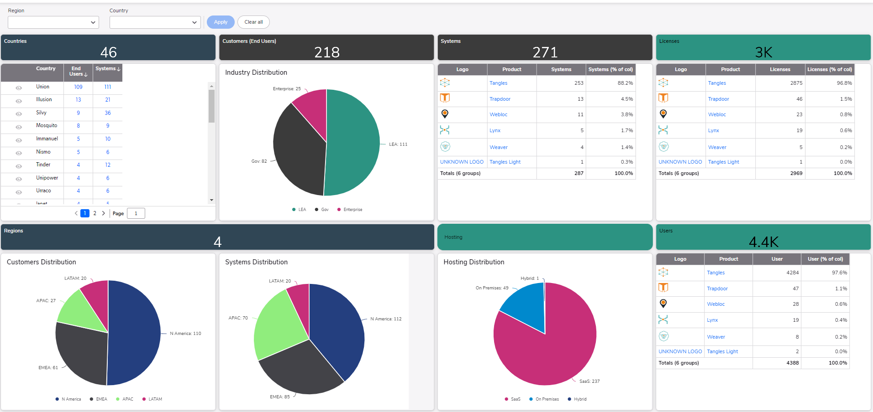
The following graphs should be available:
# | Data | Graph type | Comments
 | Number of customers and systems per country | Table | Including a caption with total countries
 | Customers distribution by industry | Pie-chart | Including a caption with total customers
 | System distribution by product | Table | Including a caption with total system
 | Number of licenses distribution by product | Table | Including a caption with total licenses
 | Number of users distribution by product | Table | Including a caption with total users
 | Number of customers distribution by region | Pie-chart
 | Number of systems distributions by region | Pie-chart
 | Hosting distribution by platform | Pie-chart | Cloud vs. On premises

Live systems
The following graphs should be available – active systems only (under contract):
# | Data | Graph type | Comments
 | Active systems and delivery projects growth by year | Table | Accumulated by year.
 | Active systems and delivery projects growth by year | Line graph | Accumulated by year.
 | Active delivered systems per Q per Year | Table | Counting, not accumulated
 | Active delivered systems per Region per Year | Table | Counting, not accumulated
 | Active delivered systems per Region per Year | Stacked column | Including a caption with total users

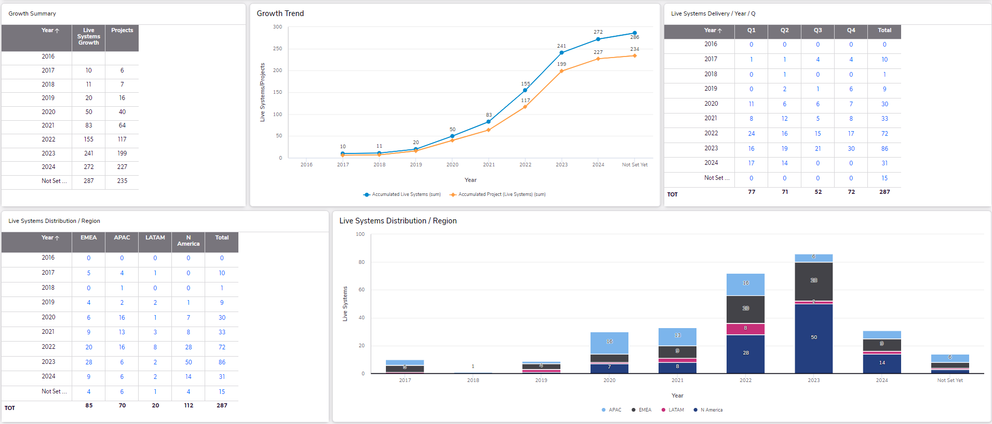

Load of work by systems
The following graphs should be available – all delivery systems (active and nonactive=under contract AND churn):
# | Data | Graph type | Comments
 | All delivered systems and delivery projects by year | Table | Active and nonactive systems (under contract).  Distinct systems and projects count per year.  The ratio between of number of delivered systems per year with the total delivered system of all times.
 | All delivered systems by Q and by year | Table | Distinct count
 | All delivered systems by Q and by year | Line graph | A line per year
 | All delivered systems and delivery projects by year and by region | Table
 | All delivered systems by year and by region | Stacked column

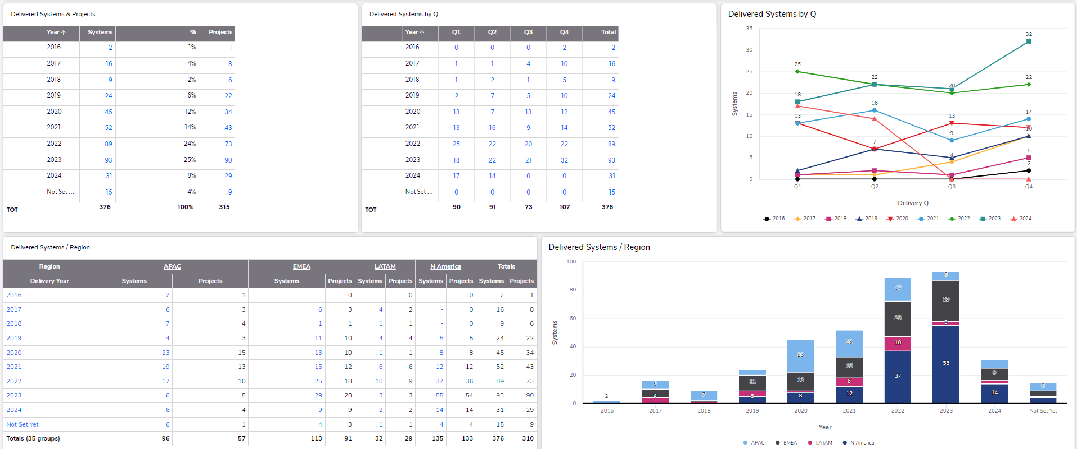

Renewal & Churns
Should include the following graphical information – active systems only (under contract):
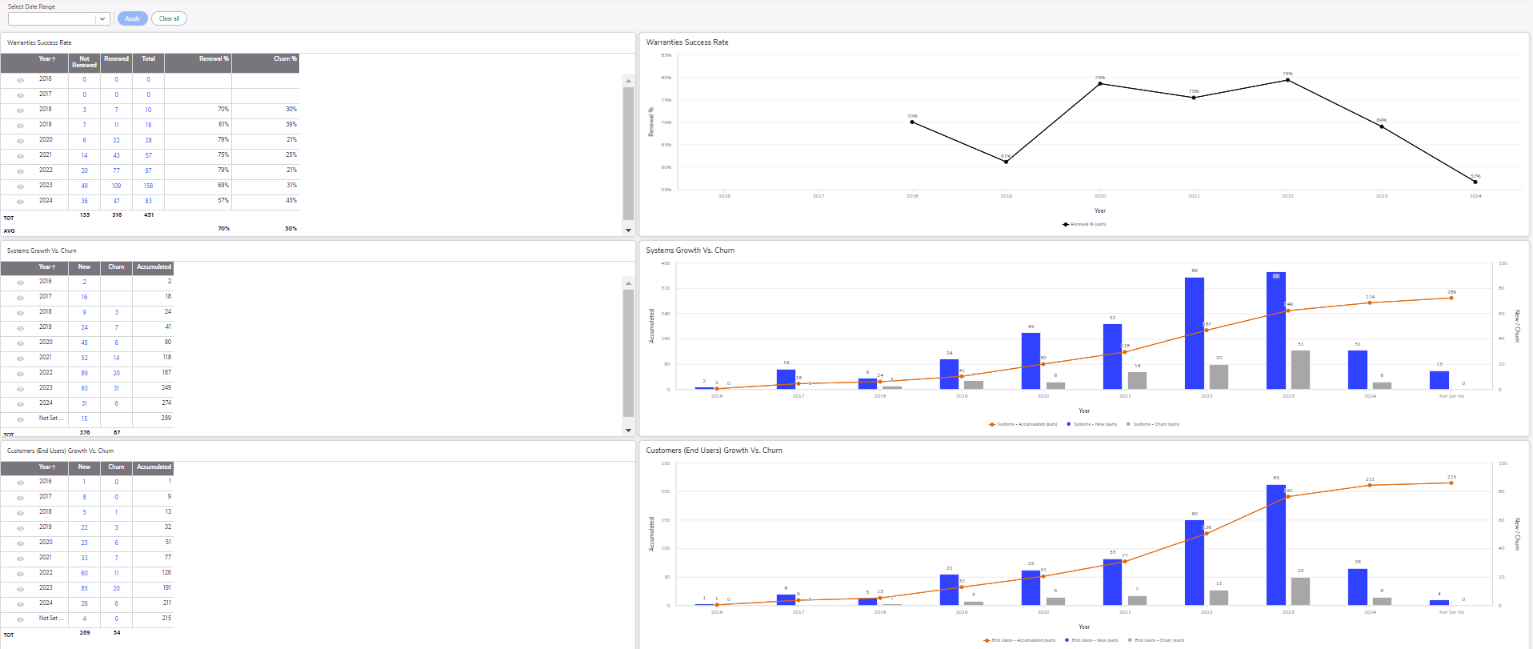
# | Data | Graph type | Comments
 | Warranties success rate by year | Table | Each entry will display how many warranties were renewed and how many were not and the ratio between them in percents
 | Warranties success rate by year | Line graph | Only the renewal percentage
 | Systems growth – new vs. churned, by year | Table | Distinct counting – new systems per year  Distinct counting – churned systems per year  Accumulated – total number of active systems after churn per year
 | Systems growth – new vs. churned by year | Combo graph – line with columns | Reflection of item 3. In this table
 | Customers growth – new vs. churned, by year | Stacked column | Distinct counting – new customers per year  Distinct counting – churned customers per year  Accumulated – total number of active customers after churn per year
 | Customers growth – new vs. churned, by year | Combo graph – line with columns | Reflection of item 5. In this table

Users/Licenses growth
Should include the following graphical information – active systems only (under contract):
# | Data | Graph type | Comments
 | Users/Licenses growth by year | Table
 | Users/Licenses growth by year | Line graph | Reflection of item 1. In this table
 | Licenses growth distribution by hosting by year | Table
 | Licenses growth distribution by hosting by year | Line graph | Reflection of item 3. In this table
 | Users’ growth distribution by hosting by year | Table
 | Users’ growth distribution by hosting by year | Line graph | Reflection of item 5. In this table

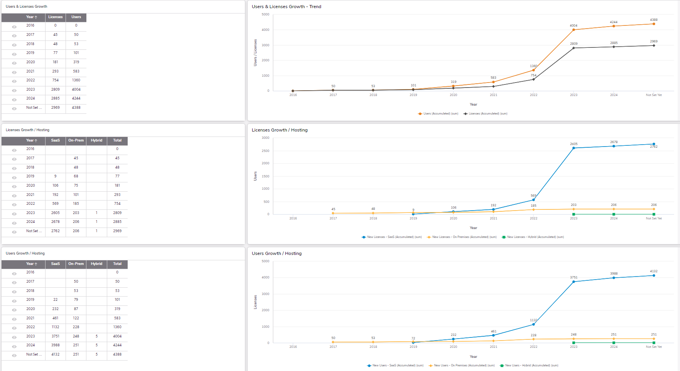

Users/Licenses ratio
Should include the following graphical information – active systems only (under contract):
# | Data | Graph type | Comments
 | Average licenses per system growth by hosting by year | Table
 | Average licenses per system growth by hosting by year | Line graph | Reflection of item 1. In this table
 | Average users per system growth by hosting by year | Table
 | Average users per system growth by hosting by year | Line graph | Reflection of item 3. In this table
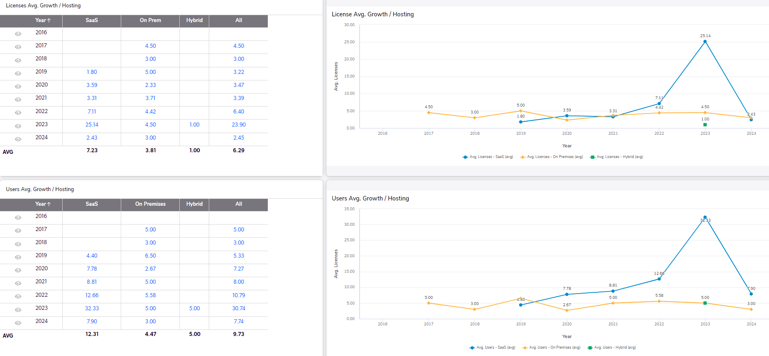

Hosting
Should include the following graphical information – active systems only (under contract):
# | Data | Graph type | Comments
 | Systems hosting distribution | Table | Total counting, percentage out of all, and projects counting per host type
 | Systems hosting distribution | Pie-chart | Distinct counting only
 | Systems hosting distribution - #hosting vs. #projects | Side-by-Side columns
 | Hosting distribution by year | Table | Distinct counting vs. percents per year
 | Hosting distribution by year | Side-by-Side columns | Distinct counting only, each column represents a year
 | Hosting growth | Table | Accumulated counting per hosting type
 | Hosting growth | Line graph | Reflection of item 6. In this table
 | Hosting distribution by region | Horizontal bars | Total counting per hosting type per region
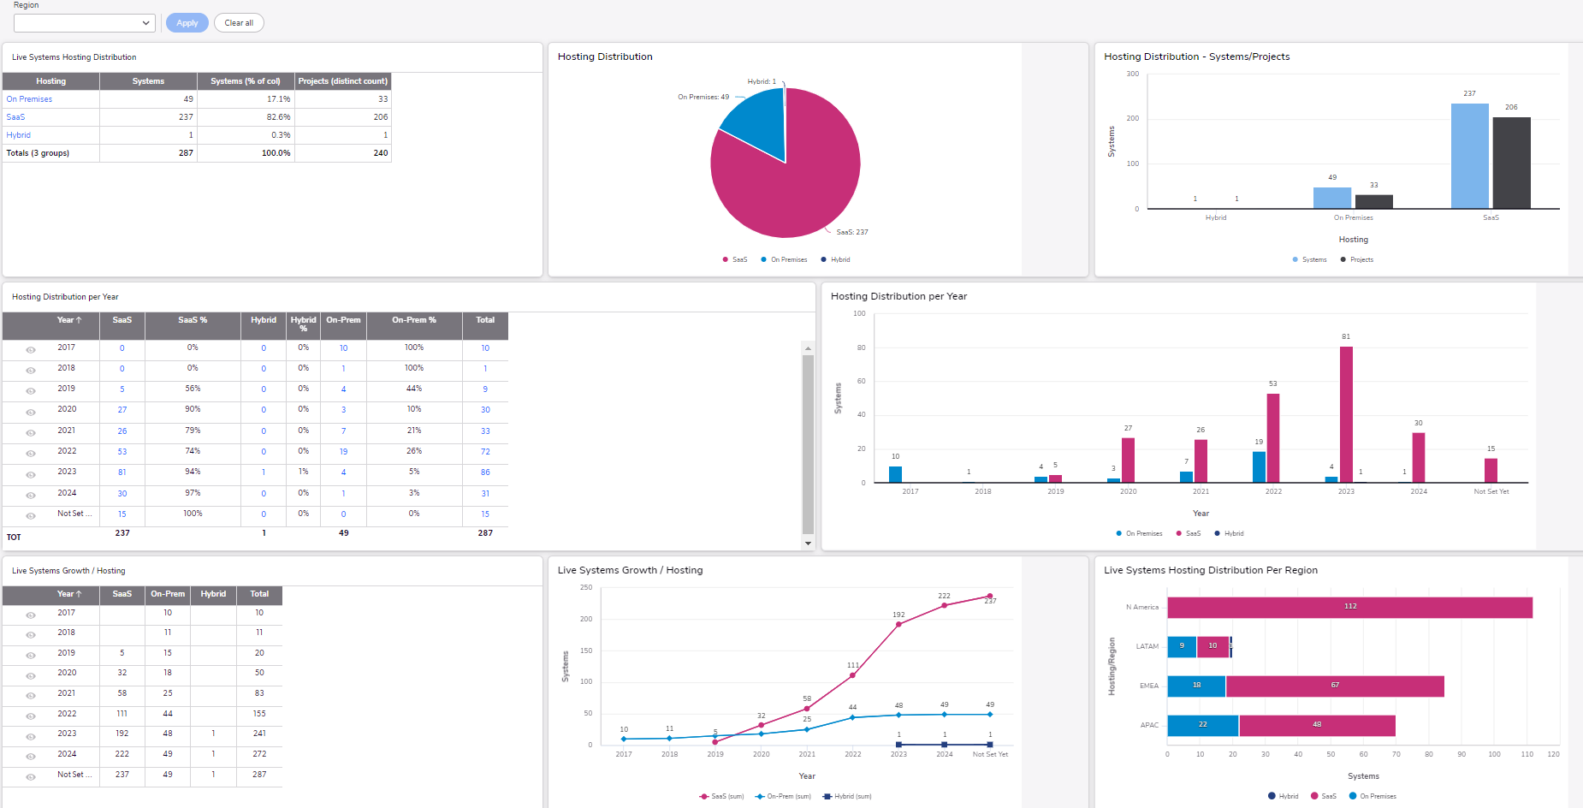

Product growth
Should include the following graphical information – active systems only (under contract):
# | Data | Graph type | Comments
 | Systems growth by Product by year | Table
 | Systems growth by Product by year | Line graph | Reflection of Item #1

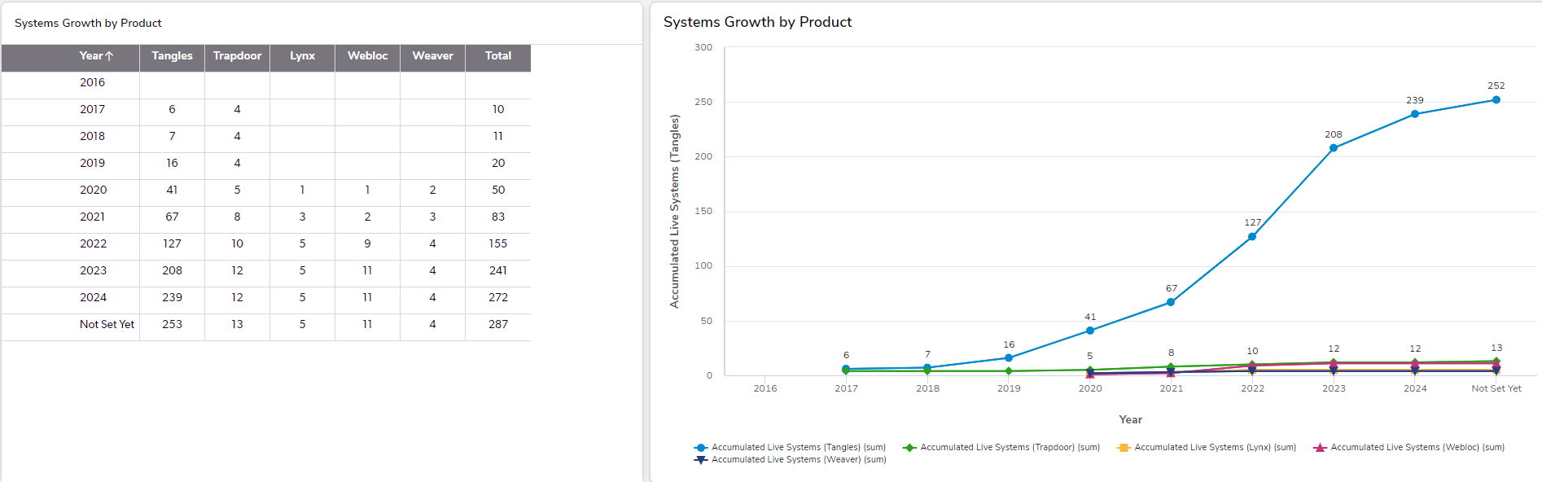

Load of work by Product
Should include the following graphical information – all delivery systems (active and nonactive=under contract AND churn):
# | Data | Graph type | Comments
 | Number of delivered systems by Product & by year | Table | Distinct counting
 | Number of delivered systems by Product & by year | Side-by-Side columns graph | Reflection of Item #1
 | Number of delivered systems by Product & number of projects per product type | Table | Distinct counting
 | Number of delivered systems by Product & number of projects per product type | Side-by-Side columns graph | Reflection of Item #3
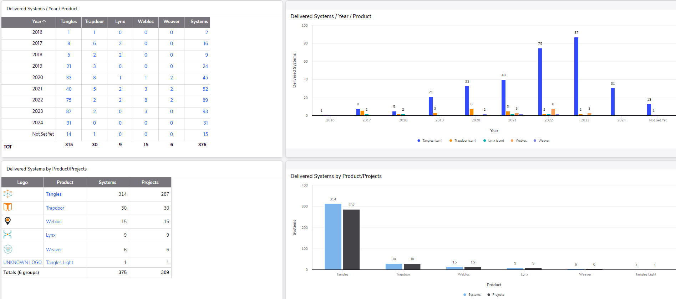

Modules & Configuration
Should include the following graphical information – active systems only (under contract):
# | Data | Graph type | Comments
 | Number of systems per modules configuration | Table | Sorted largest to smallest
 | Number of systems per modules configuration | Columns graph | Reflection of Item #1
 | Modules counters per Product type | Table | Distinct counting
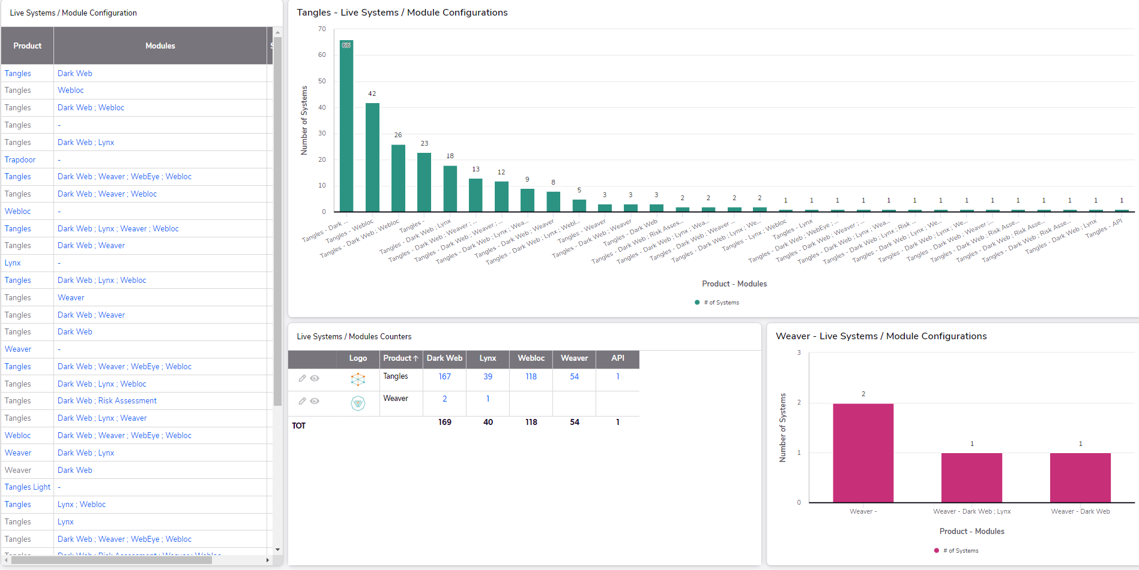

Regions & Countries
Should include the following graphical information – active systems only (under contract):
# | Data | Graph type | Comments
 | Systems and projects distribution by region | Table
 | Systems distribution by region | Pie-chart
 | Systems and projects distribution by region | Side-by-side columns
 | Systems and projects distribution by country | Table
 | Systems and projects distribution by country | Side-by-side columns | Countries code names
 | Systems and projects distribution by US’s states | Table
 | Country growth trend by year | Combo graph | (1)New per year (2)churned (3)growth/accumulated along the years
 | Country growth trend by year | Table | (1)New per year (2)churned (3)growth/accumulated along the years
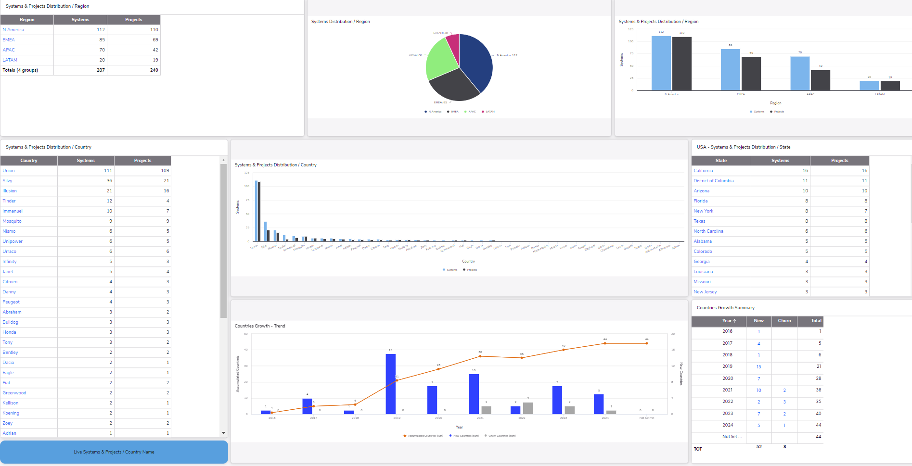

Modules distribution by regions
Should include the following graphical information – active systems only (under contract):
# | Data | Graph type | Comments
 | Modules distribution by region | Table
 | EMEA - modules configuration combination by number of systems | Columns
 | APAC - modules configuration combination by number of systems | Columns
 | NA - modules configuration combination by number of systems | Columns
 | LATAM - modules configuration combination by number of systems | Columns
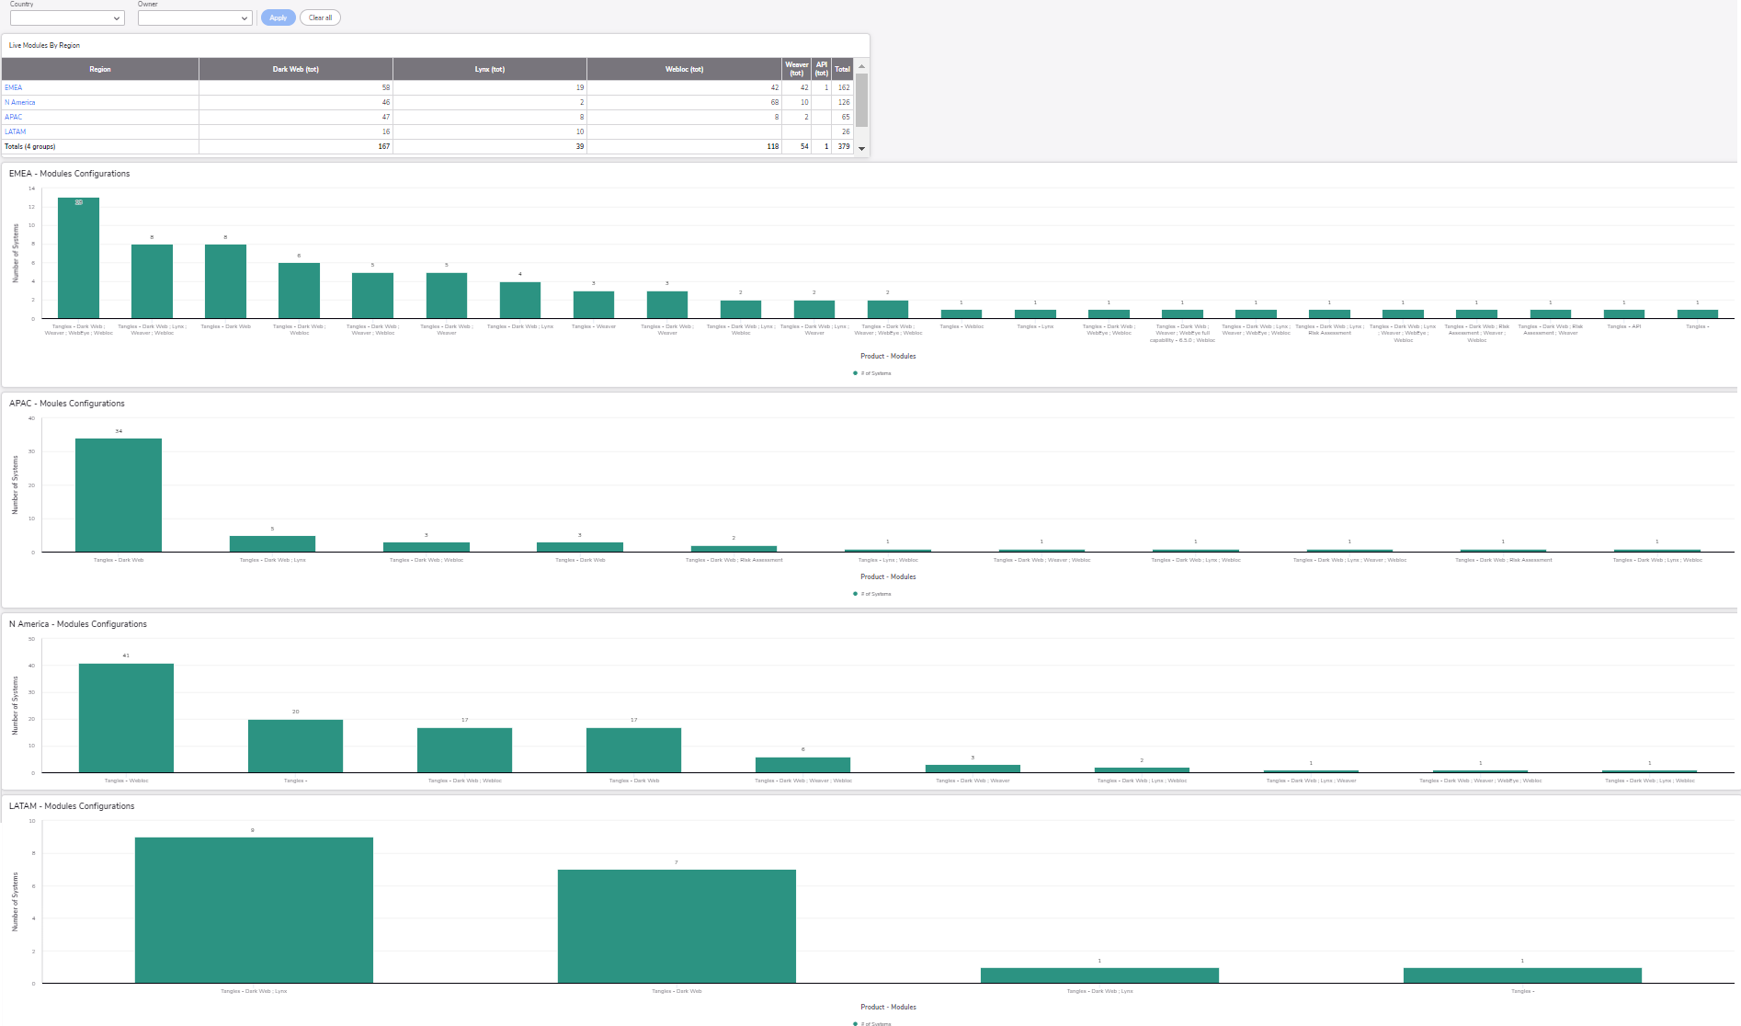

AI configuration
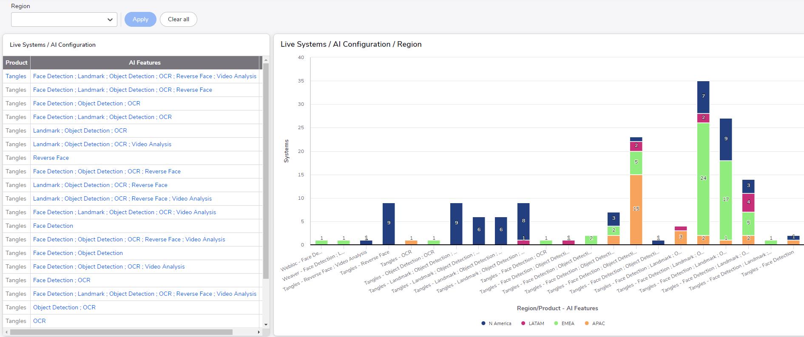
Should include the following graphical information – active systems only (under contract):
# | Data | Graph type | Comments
 | AI configuration combination by number of systems | Table
 | AI configuration combination by region | Stacked columns

AI Distribution
Should include the following graphical information – active systems only (under contract):
# | Data | Graph type | Comments
 | Number of system w/o AI per product type | Table | In absolute numbers and precents
 | Tangles - number of systems w/o AI | Pie-chart
 | Weaver - number of systems w/o AI | Pie-chart
 | Number of system w/o AI by region | Side-by-side columns
 | System with AI growth by year | Table
 | System with AI growth by year | Combo graph | (1)New per year (2) growth/accumulated along the years
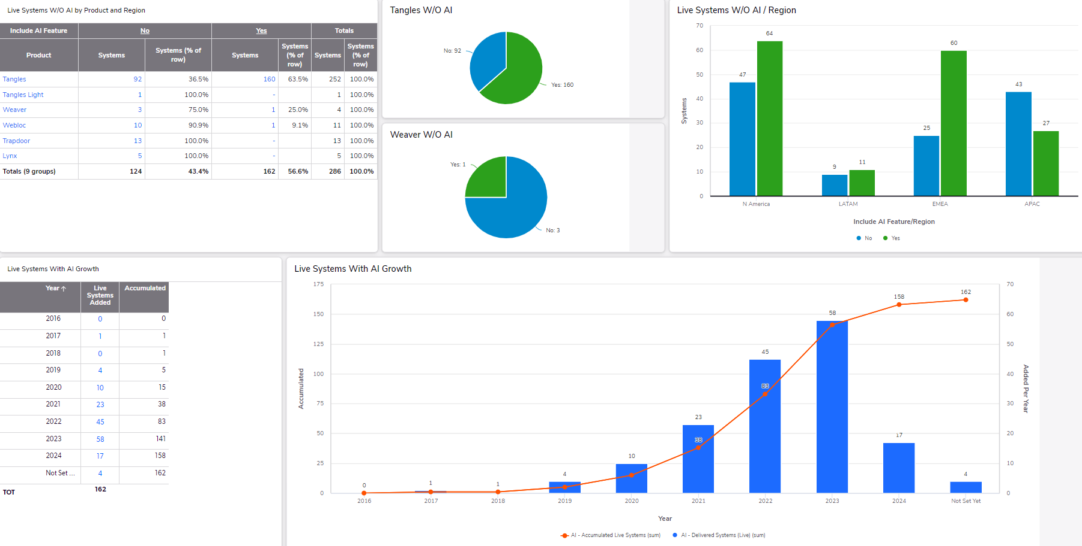

Webloc Distribution
Should include the following graphical information – active systems only (under contract):
# | Data | Graph type | Comments
 | Number of system w/o Webloc as a module per product type | Table | In absolute numbers and precents
 | Tangles - number of systems w/o Webloc as a module | Pie-chart
 | Weaver - number of systems w/o Webloc as a module | Pie-chart
 | Number of system w/o Webloc as a module by region | Side-by-side columns
 | System with Webloc as a module growth by year | Table
 | System with Webloc as a module growth by year | Combo graph | (1)New per year (2) growth/accumulated along the years
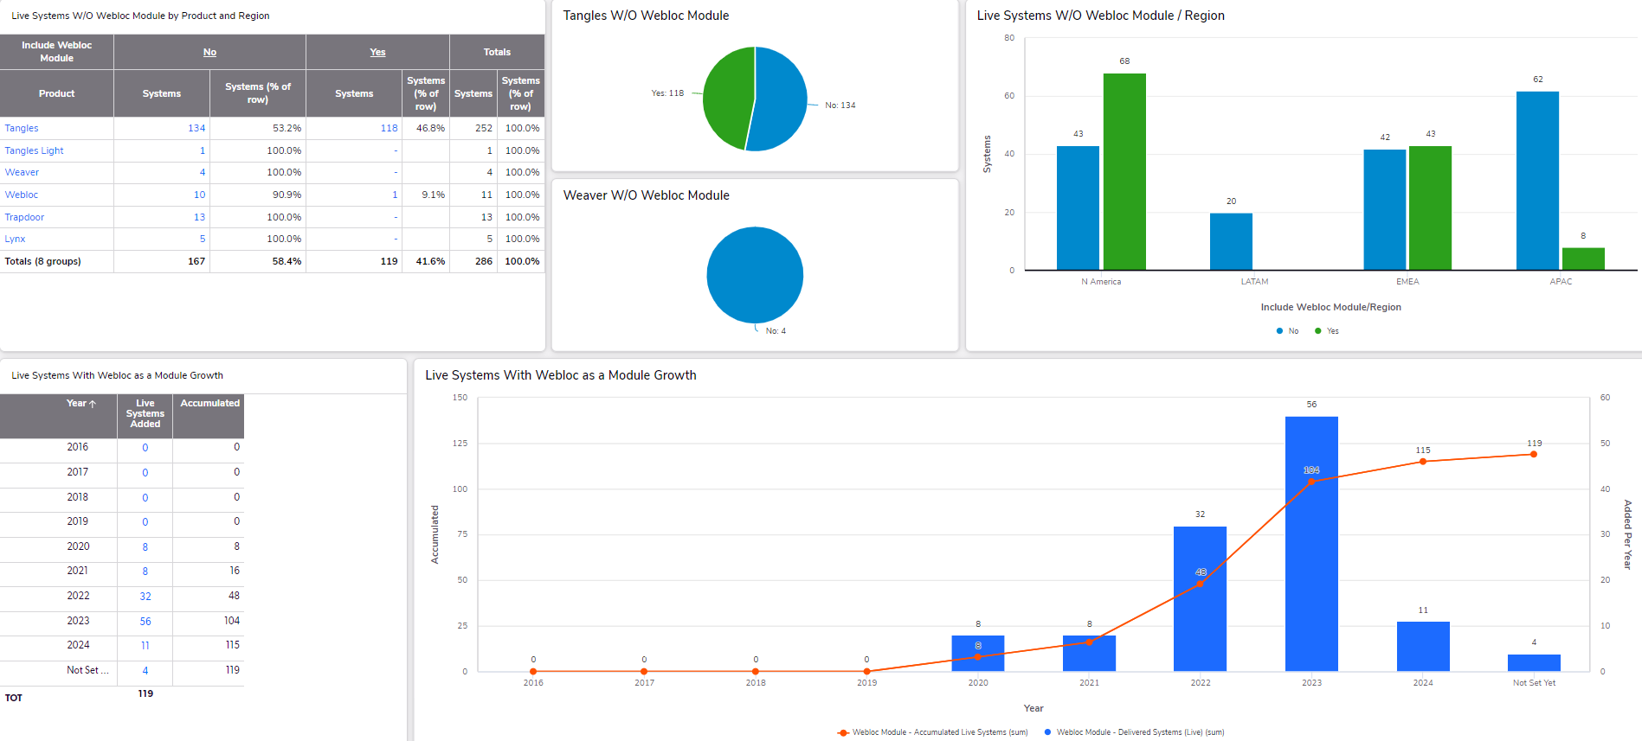

POCs

Summary
Should include the following graphical information – active systems only (live projects), including. Filters: by region and by country:
# | Data | Graph type | Comments
 | Total of current live POC projects | Counter
 | Total of current countries that have live POC projects | Counter
 | Total of current customers that have live POC projects | Counter
 | Total number of systems in current live POC projects | Counter
 | Total number of licenses in current live POC projects | Counter
 | Total number of users in current live POC projects | Counter
 | Existing #customers, #prospects, #projects, #systems per country | Table
 | Industry type distribution | Pie-chart
 | Product type counting | Table
 | Number of licenses per product type | Table
 | Number of users per product type | Table
 | Customers distribution by region | Pie-chart
 | Systems distribution by region | Pie-chart
 | Hosting distribution | Pie-chart
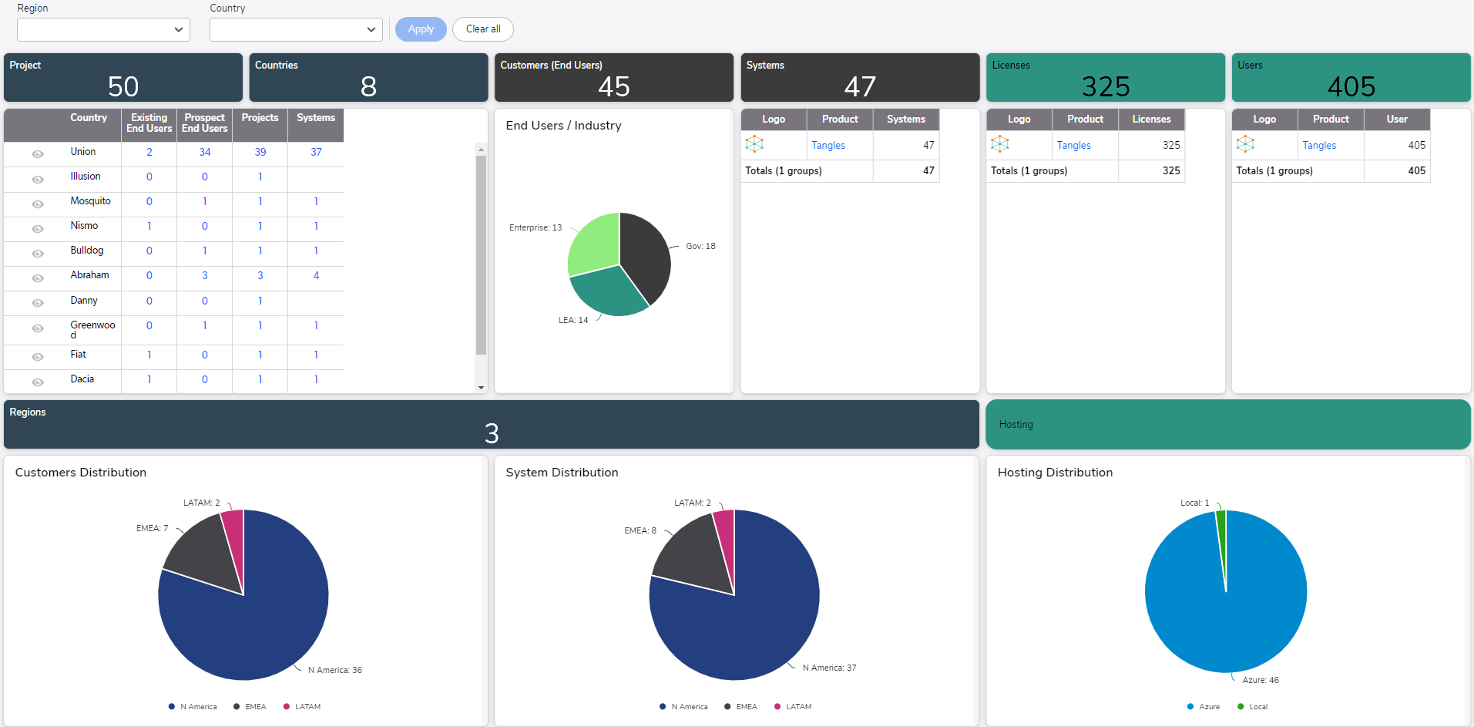

POC per Year
Should include the following graphical information – all systems and POCs history:
# | Data | Graph type | Comments
 | Number of systems and projects by year | Table
 | Number of systems and projects by year | Side-by-side columns
 | Number of systems per product type by year | Table
 | Number of systems per product type by year | Side-by-side columns
 | Number of systems and projects by year by region | Table
 | Number of systems and projects by year by region | Side-by-side columns
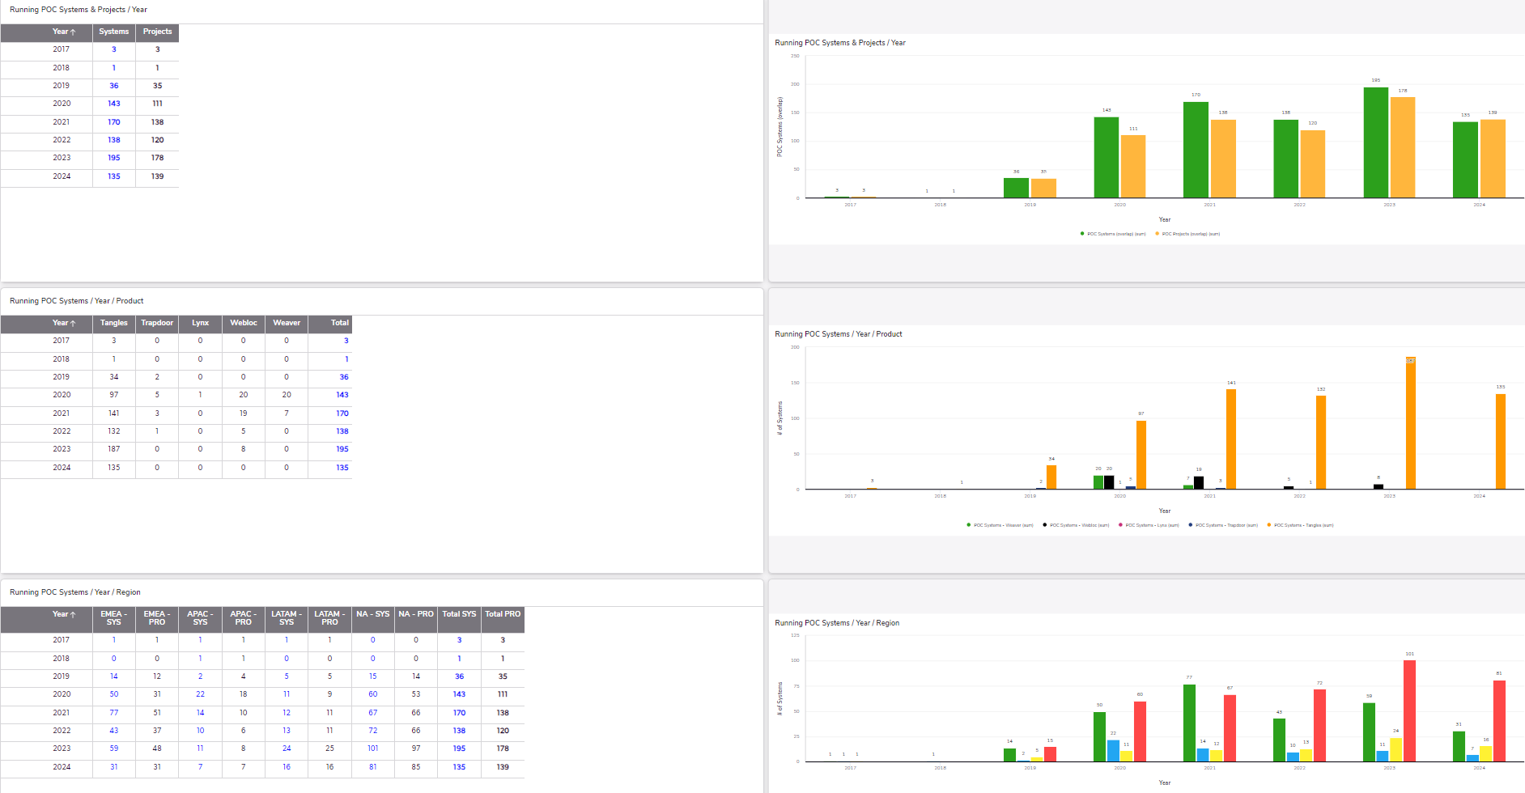

Success rate and Cost
Should include the following graphical information – all POCs of current and last year only. Filters: by region
# | Data | Graph type | Comments
 | Current number of live POCs | Counter | In absolute numbers and precents
 | Current live POCs average duration | Counter
 | Current live POCs total cost | Counter
 | This year POCs cost (YTD) | Counter
 | Last year POCs success rate | Table | Total vs. duration vs. paid/no paid vs. won/not won and won percents
 | Current year POCs success rate | Table | Total vs. duration vs. paid/no paid vs. won/not won and won percents
 | Live POCs system cost | Table | Full details (e.g. project name, start/end date, infra and consumption cost etc.)
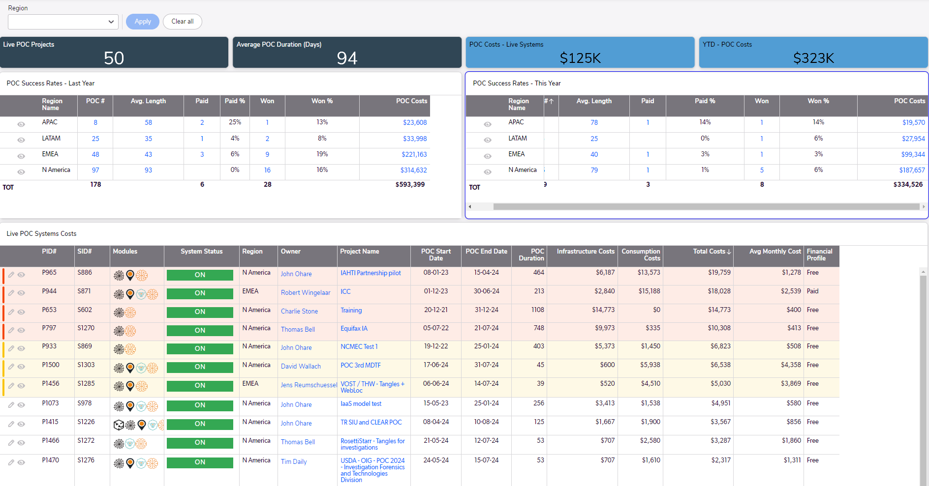

Load of work by system
Should include the following graphical information – all systems and POCs history:
# | Data | Graph type | Comments
 | Number of systems and projects by year | Table | #Systems – absolute and percents
 | Number of systems by year by Q | Table
 | Number of systems by year by Q | Multi lines graph
 | Number of systems and projects by year by region | Table
 | Number of systems by year by region | Stacked columns

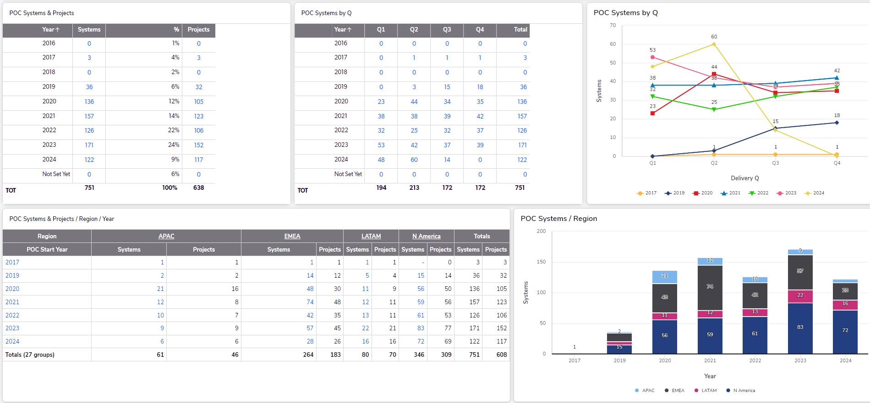

Load of work by product
Should include the following graphical information – all systems and POCs history:
# | Data | Graph type | Comments
 | Number of systems by product type by year | Table | In absolute numbers and precents
 | Number of systems by product type by year | Side-by-side columns
 | Number of projects by product and systems by year | Table
 | Number of projects by product and systems by year | Side-by-side columns

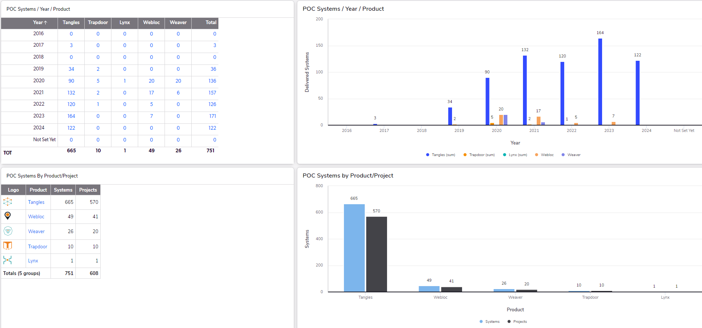

Hosting
Should include the following graphical information – all systems and POCs history:
# | Data | Graph type | Comments
 | Number of systems per hosting type | Table | #systems – absolute and precents
 | Hosting distribution by systems number | Pie-chart
 | Hosting distribution by systems number | Columns

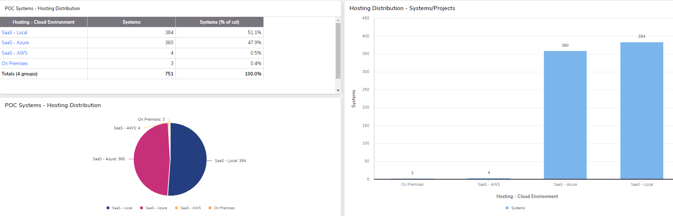

Modules configuration
Should include the following graphical information – all systems and POCs history:
# | Data | Graph type | Comments
 | Modules configuration combination by product type and number of systems | Table | In absolute numbers and precents
 | Modules district counting by product type | Table
 | Weaver only – count of modules configuration combination | Columns
 | Tangles only – count of modules configuration combination | Columns

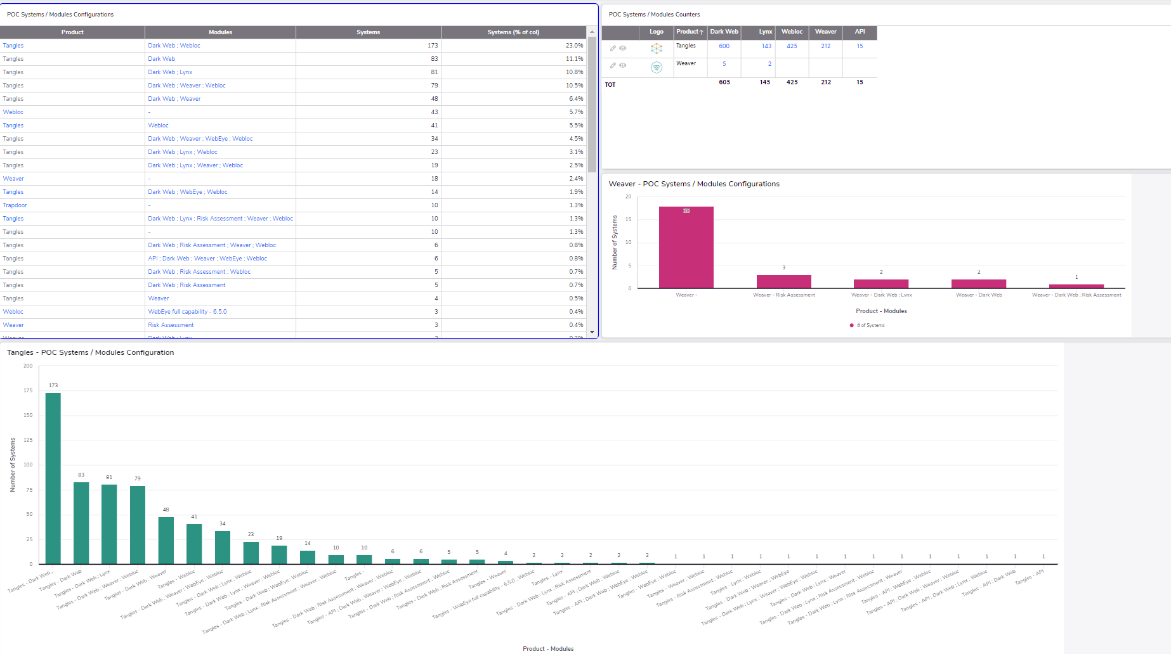

Regions & Countries
Should include the following graphical information – all systems and POCs history:
# | Data | Graph type | Comments
 | Systems and projects counting per region | Table | In absolute numbers and precents
 | Systems counting per region | Pie-chart
 | Systems and projects counting per region | Side-by-side columns
 | Systems and projects counting by country | Table | Countries code name
 | Systems and projects counting by country | Side-by-side columns
 | Systems and projects counting by US state | Table
 | POC growth | Combo graph | (1)New per year (2) growth/accumulated along the years
 | Number of countries per year and accumulated | Table
 | Systems and projects counting by country | Link | Link to a table with countries real names
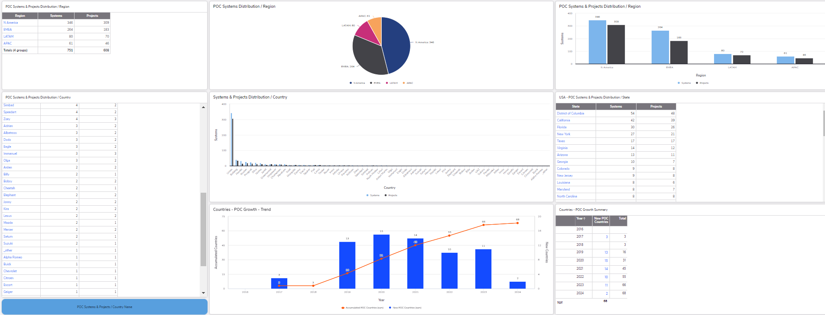

Modules distribution by region
Should include the following graphical information – all systems and POCs history:
# | Data | Graph type | Comments
 | POC modules by region | Table | In absolute numbers and precents
 | APAC - modules configuration combination | Columns
 | EMEA - modules configuration combination | Columns
 | NA - modules configuration combination | Columns
 | LATAM - modules configuration combination | Columns
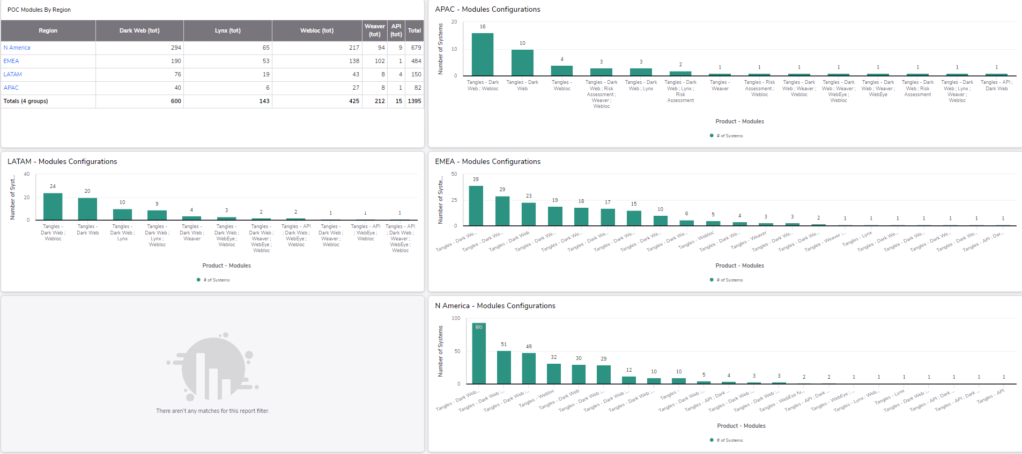

AI configuration
Should include the following graphical information – all systems and POCs history. Filters: by region
# | Data | Graph type | Comments
 | AI configuration combination by number of systems | Table
 | AI configuration combination by region | Stacked columns
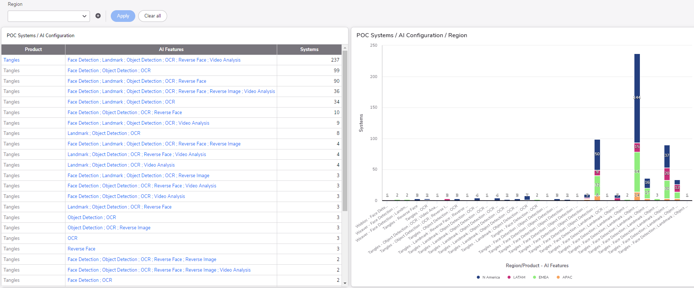

AI Distribution
Should include the following graphical information – all systems and POCs history:
# | Data | Graph type | Comments
 | Number of system w/o AI per product type | Table | In absolute numbers and precents
 | Tangles - number of systems w/o AI | Pie-chart
 | Weaver - number of systems w/o AI | Pie-chart
 | Number of system w/o AI by region | Side-by-side columns
 | System with AI growth by year | Table
 | System with AI growth by year | Combo graph | (1)New per year (2) growth/accumulated along the years
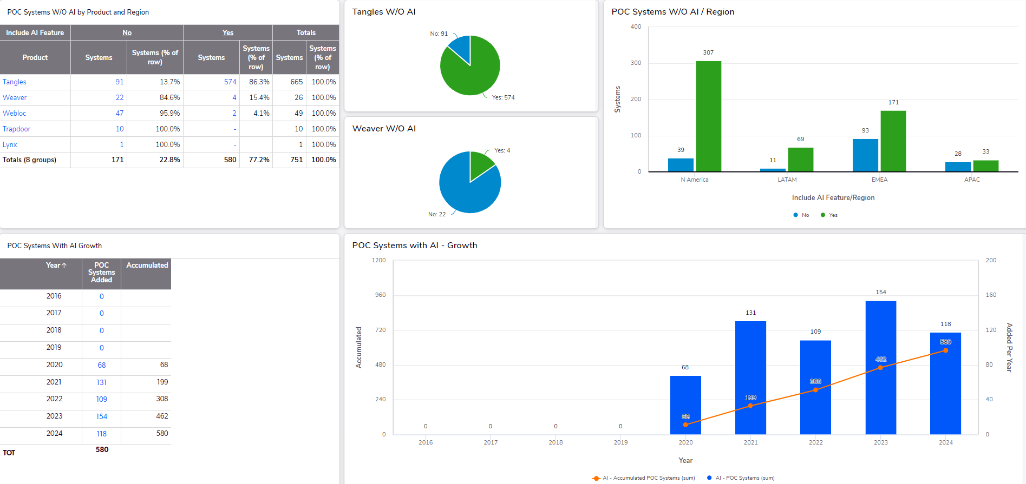

Team Activity
Should include the following graphical information – all systems and POCs history. Filters: by region, by country, by owner.
# | Data | Graph type | Comments
 | Number of POCs projects per month | Columns | Last 13 months
 | Number of POCs projects per month per region | Side-by-side columns | Last 4 months
 | Number of POCs projects per month per owner | Side-by-side columns | Last 4 months
